EARLY DAY CARE AND SETTING UP OF
MARJORIE MANN LAWLEY DAY CARE CENTRE

As transcribed from a tape recording (2001) by Marjorie Mann as part of her life history.

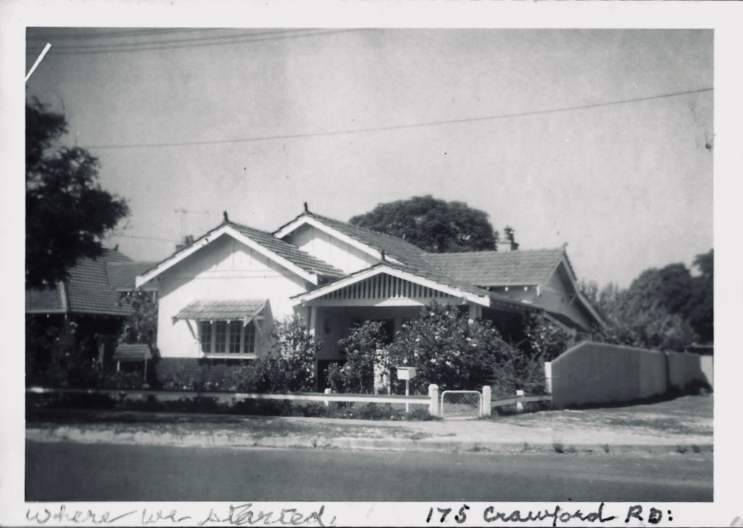
Original nursery: 175 Crawford Rd Inglewood.

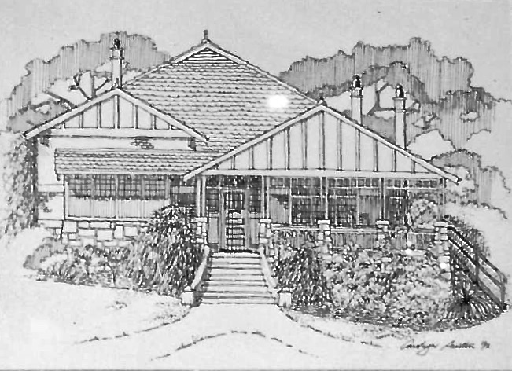
Artist impression of Mt Lawley house prior to becoming the current day care centre.
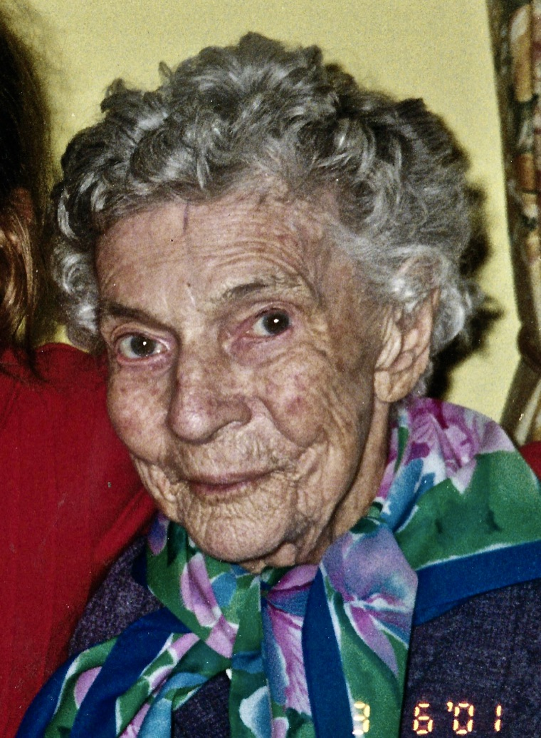
I look back on those 6 years at Saint Albans Highgate, as 6 wonderfully happy years. It was indeed a wonderful happy time. And then, sadly Frank (Marjory’s husband and Rector at St Alnbans) became very ill and it meant that he had to retire in 1963.
We were fortunate again that we had a house to go to. Many years previously an uncle had left some money to us and we had put a deposit on a house in Inglewood. It was a dear little house.

While Frank was ill recovering from his stroke, I decided I should get a job somewhere and so looked around and eventually found part-time work at the Children’s Protection Society in Beaufort St, Highgate. It was just down the road from where we had lived in Highgate and an easy bus ride from Inglewood. I worked there for a short time in the afternoons on two days each
week until Frank became ill again and I stopped to care for him.

Marjory Mann aged 92
After Frank died (1964) and time went by and I knew that I ought to try and get some sort of job. I re-applied for my old position at the Children’s Protection Society and a short time later I also trained to join the Samaritans.

I joined Samaritans and there I had met many good people but someone there I got to know well, a lady called Rita Murphy. She had done her Mother Craft training and she was a fully trained Mother Craft Nurse - and having quite a large family of small children – she had a lot of experience with babies and small children. We thought to start a day care place for needy families.
While at the day time centre where I had learnt a lot (at the Children’s Protection Society) and while there had met a very nice woman that we included, Freda Waldron. We three talked together and decided we’d start a little day care centre in my house, for children in special need and of course parents in special need. So, we started this idea together. (Rita says one of the reasons for this discussion was the number of calls for help from single mothers for help with care for babies.)

There were very few day care places for little children. I think we were the first in Perth and it was known then as Children’s Protection Society and had been started, oh, a number of years previously, by a committee of people who were worried about the children that were locked in their homes while their mothers went out daily to work. They started this and I worked there for some time in the afternoons for just about three hours.

I felt we could open in a small way in my house. We would be allowed; I think it was five children and this would be a start. So, we talked to Miss Pearce – she was head of a government department dealing with day care centres and was connected with all sorts of things. She was a wonderful woman and eventually we became close friends and one we always looked up to and from whom we got a lot of very valuable advice and help. And then when we were finally accepted and registered we set up and started with a brother and sister (1968).

Original day care and home of Marjory Mann

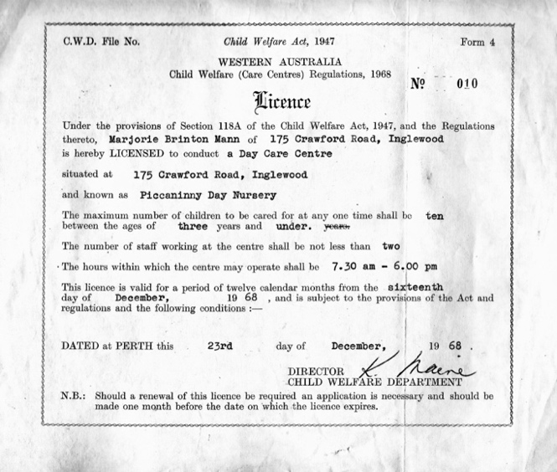
First licence for day care at 175 Crawford Rd

So, anyway, we started in a very small way in my home and of course there were all sorts of things we had to do and it had to be just right. There were strict rules and gradually we had everything as we should. And that was a very happy time there.

I think we started with 2 little children (one a baby) and quickly had about 6 children and then gradually worked up as time went by, until we had 13 children including some who were after school care only.
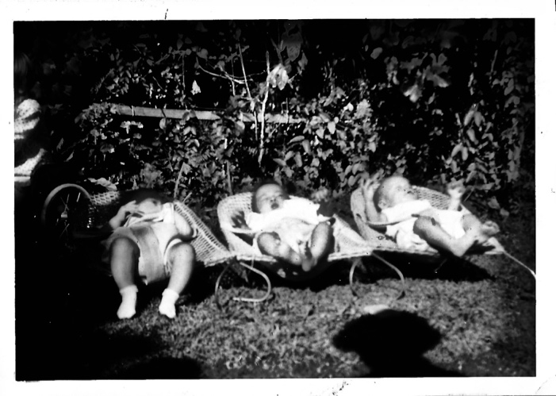
The Nursery’s first three babies (there was one other 2 year-old as well).

We stayed like that for about 18 months and this Margorie Pearce, who was the advisor for Child Care in those days (the only one). She was a wonderful woman and she said with the need we must get into bigger premises. There was no one who took little babies in those days. Any mother on her own, deserted or in any way a single mother or a father deserted, they had nowhere to put their little babies. So, we had quite a long list of people with babies and toddlers waiting for us. I think we had 30 on our list by the end of the 18 months, waiting for bigger accommodation.

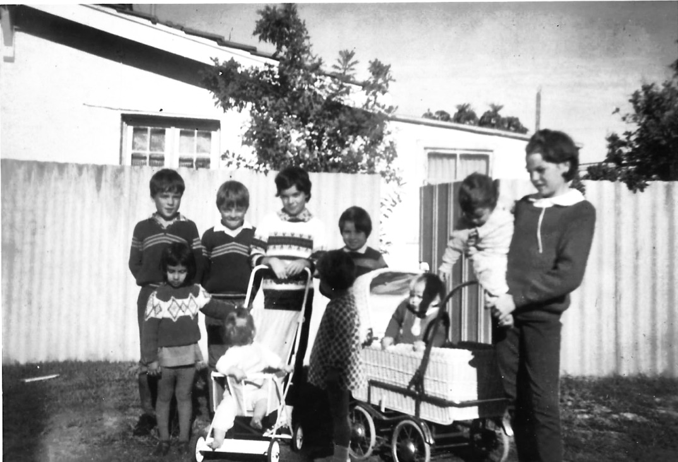

Some of children at 175 Crawford Rd including after school care children.

So, at last we decided to have a meeting, which we had at St Francis Hall in Inglewood, and at that meeting we corresponded and got in touch with a lot of people who we thought might be interested. And we got a lot of people through our Churches: Rita a Roman Catholic, Freda Waldron was a Uniting Church and me an Anglican, interested in what we were doing. And we had a wonderful man. He was a lawyer and a good Christian man and at our meeting, I think when people looked at this sensible lawyer and Miss Pearce, they realised that we did have something going for us and I think we only had about $5 and a few cots and things like that, that we had in my home, which we had got through asking people and then over the radio. And from that meeting we got the interest of a lot of people and we got a Committee going.

Michael was at home all through this time and every weekend on Friday night I would put the dining room back to normal because our dining room was the children’s play area normally. But, I would turn it back into a dining room and we would have a normal home over the weekend. My bedroom was stacked up with chairs and all sorts of things and I just had a little track to my bed. They were discomforts but, we felt we were helping people and we had some quite small babies at that stage and that for many years afterwards actually.

Our great need of course was bigger premises and it now became the really big search. Freda, Rita or I would see their advertisements or hear from friends of a house that perhaps would be possible to buy. Our committee worked hard, as we did ourselves, trying to raise money with concerts and all sorts of things. All the time we were raising money and of course at that stage there was no help and we were in need of Government money to assist in any way.

Our aim was to have a day care centre for those in need, not for wealthy people who would perhaps like to go to work or enjoy it, but for people who really had to go to work. Because in those days that was where the mothers of little babies had a rough spin, because they only got money from the government for 3 weeks before the baby was born and 3 weeks after to be back at work. This was how we came to have so many little ones. But, Children’s Protection Society was still but open, but they never took little babies there, I think no children under about 18 months.

So, our search began and lasted some months. I think then Rita heard of a big old home in Mount Lawley owned by the Roman Catholic Church. They had had it as a sort of boys’ home and were changing it and they hadn’t decided what to do with it. So, she went to the Archbishop (Archbishop Goody) and asked if we could rent it and they were kind to let us rent it very reasonably (Peppercorn rental as Rita says) and it was the perfect place. It had plenty of rooms and we planned to have 30 and so we did end up having 50 there with one room added actually. But, at the beginning we only wanted 30. It was ideal.

So, when that was arranged, then we all asked people in our churches if they would help and they helped in all the different ways. Some friends of Rita’s friends came in and painted inside all for nothing. We contacted other people and shops and so on and the paint was all given for nothing. (Rita said Mr Stone, then President of Mt Lawley Rotary, was of great help).

I arranged with a radio station, I think it was 6IX, (as they used to appeal for different people who needed things) and they put out a lot of appeals and got cots and high chairs, sheets, blankets and of course they were all big sheets and adult towels but, we cut them down and the towels and made them to the size we required. Pots and so on. Then the Youth Fellowship at St Francis Church (Inglewood) where we were then going to church (Michael and I), their youth group came in and they painted all the furniture and made it look fresh and neat and they did other things and came and helped in other ways.

Freda’s Church were very good, they provided (as far as I can remember), all heating and lighting and so on. They gave us about 2000 pounds (I think it was then, but actually dollars). So, there was a real job done by the different Churches.

Actually, we had hoped that perhaps we could get the three churches to back us up. We got the Archbishop (the Roman Catholic Archbishop, Archbishop Goody)): Rita got him out and I remember making him a real sponge cake for the afternoon tea and then at last the Anglican Archbishop came out. We also provided him with a sponge cake. But it wasn’t enough to quite get to their hearts. They were behind us, but I think they were scared it would cost them in an awful lot of money, which actually it would not. Of course, the Government came in just soon after but none of us knew that at the time. (Rita pointed out that this day care centre was the first to receive money from the Government for renovations and extensions.)

But all the Christian people of the different Churches did help wonderfully in our efforts. It was wonderful how enough furnishings came in for the whole place. Some were old but painted and bits cut up and sewed we had all we needed and we opened up.

When we moved from my home to Mount Lawley again our lovely President, he and his son, carted things and Michael carted things. It took two weekends for us to get everything across and then we were able to open up straight away with the 30 children waiting. I can’t remember how many of the original age groups there were: probably about 4 or 5 babies, from 3 weeks (Rita thinks it was 6 children from 6 weeks to 4 years). And here was Rita, who was a Mother Craft Nurse, who was wonderful. She was of course put in charge of the babies. (Not only being a Mother Craft Nurse but she had 6 children of her own). So, she was very knowledgeable there. Freda Waldron, who understood money, (I would have been hopeless there). Freda was excellent, she did all the money side. Of course, she helped with the children too, but her main job was money. We charged very little because the mothers we had and all the fathers couldn’t afford much but we did have to charge a little but, a little salary. And we had mostly voluntary help. Freda, Rita and I had a little salary. I can’t remember but probably $20 per week or something like that if there was enough. If there wasn’t then we didn’t. And we sort of had everything going well.

Miss Pearce, of course, came out and oh there were a great many regulations we had to do things to the house to make things very safe for the children and there was a lovely big garden both front and rear. And we asked the Clinic Sister from Inglewood if she would visit us once a week and look at all our babies. She was a wonderful person and was a great help to us all the time. All those years, came for years and years. She used to come in about 5 and stay until the last mother who would like to see her came in for their children so she could talk to them about their children without us hearing them and if they had a complaint they could tell her. She really encouraged us and helped us too, although she started really at my house in Inglewood and came in to our bigger centre in Mt Lawley with us.

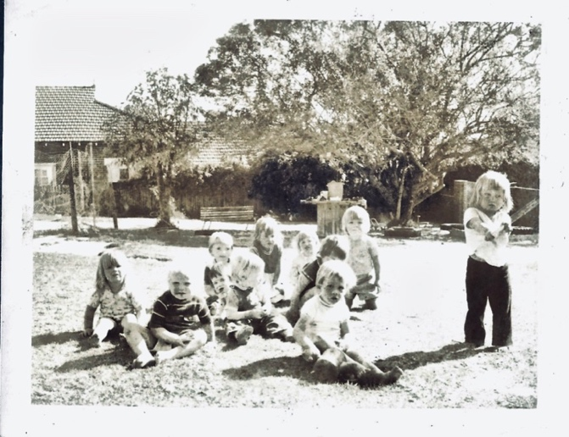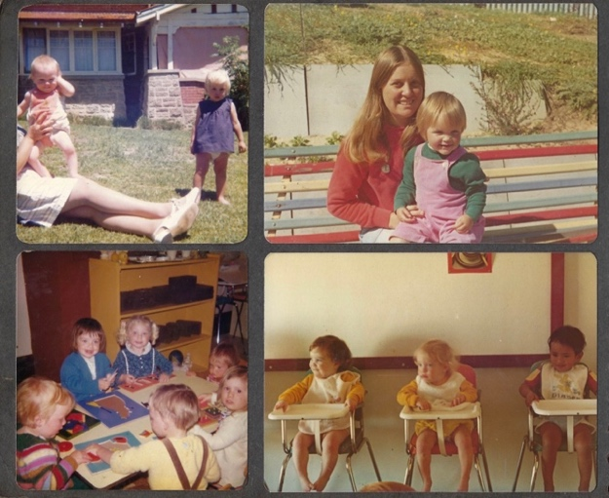

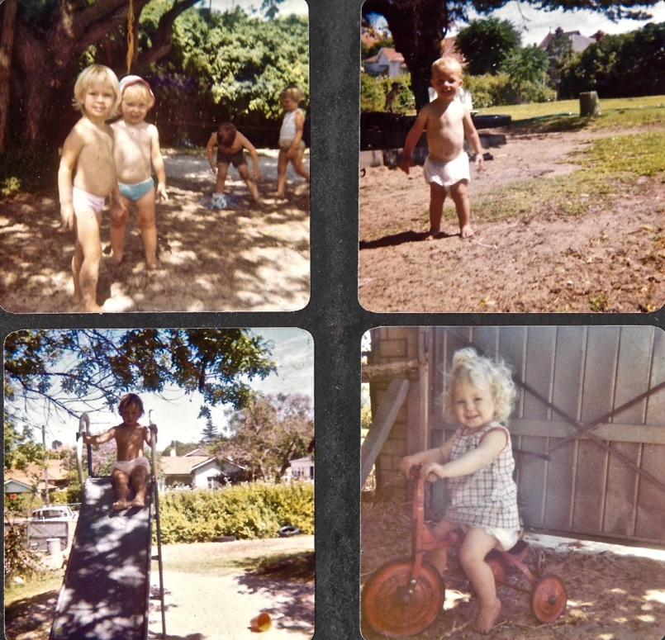
Early days at Mt Lawley

We also, after a little while we, had a Chaplain. I had the idea that it would be really good to have a Chaplin. Somebody who was kind and loving and who would take an interest in our mothers and fathers who that stage more often were very lonely. So, we asked a friend if he was available, he was living in the hills and he became it, and was our president twice and came for our monthly meetings. He was wonderful with them and it didn’t matter what their denomination (they were in). And he came to all our groups we were in so he could really get to know them and he ended marrying two of them. Lovely person.

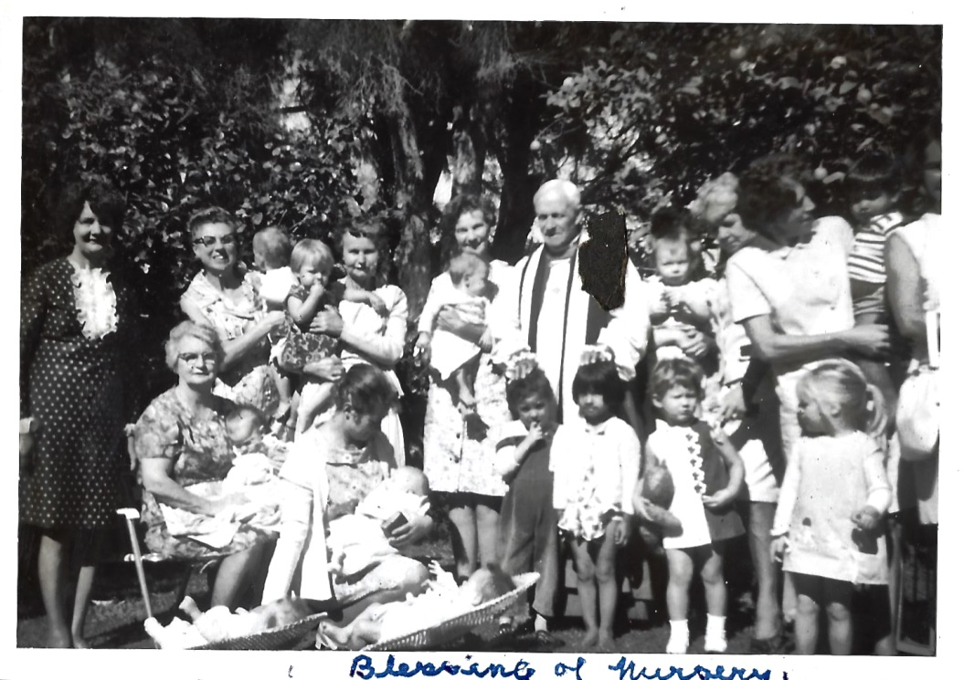
Consecration of nursery with Bishop Frewer, Staff and children

One of them, very much on her own with a little boy. I think he was four and she married a very nice man and she had no room for a reception and so everyone rallied around and we gave our biggest room and got it all set up with all the necessary furniture and items with nice tables and we had the reception there. He had married her in the local church and our voluntary helpers put in 2 or 3 cakes and other bouquets for the bride and groom and it really was a beautiful wedding.
The second wedding, the mother was an older and she had the money for the reception. She had a reception in a local town hall and again a lovely wedding was had.

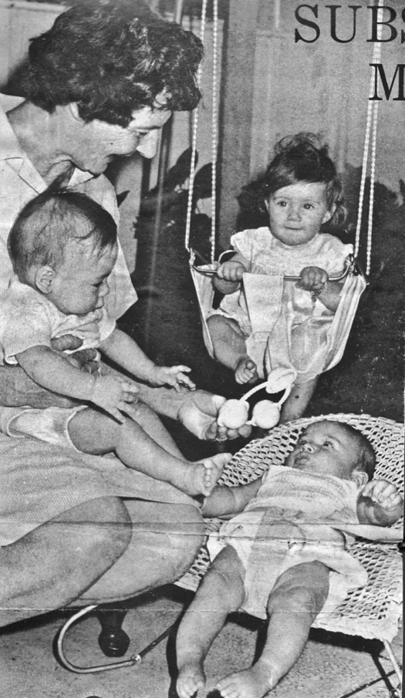
Marjorie Mann with babies (her favourite age group).
(Picture from local suburban paper)

The three ladies who are responsible for starting Marjorie Mann Mount Lawley Day Care Centre

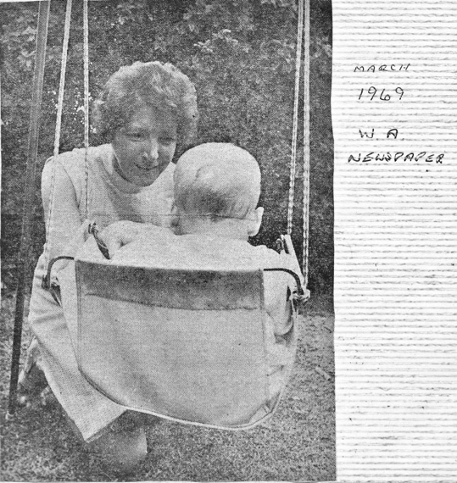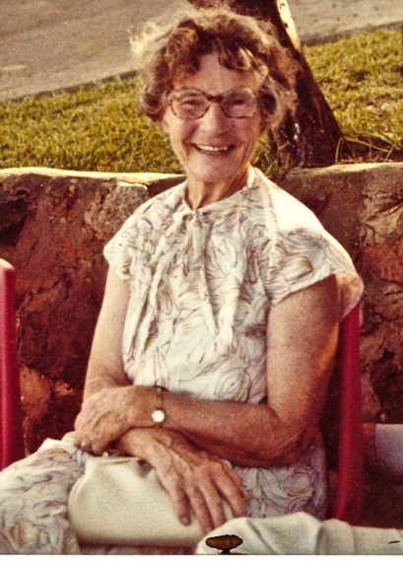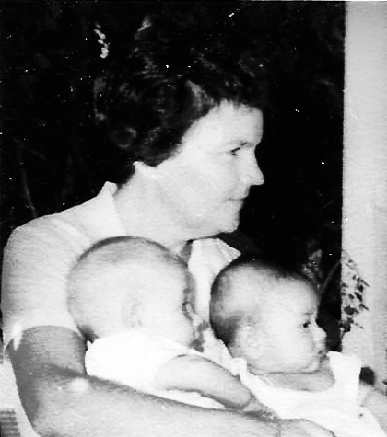
Freda Waldron Marjorie Mann Rita Murphy

January 2020 there was 104 children from 89 families being cared for by 22 staff (both full and part-time). A far cry from the initial 6 children the nursery started with.

Acknowledgements
Transcribed and collated by Michael Mann (son of Marjorie) in 2019.
Rita Murphy (Co-Founder)
Sinead McCarthy (City of Stirling Property Management)
Staff Marjory Mann Mt Lawley Day Care Cerntre

ADDENDUM

Comments in italics were from a letter received by the nursery from one of the founders Mrs Rita Murphy. I thank her for her help in recalling the history of this Day Care Centre.

In 15 November 1973 the City of Stirling purchased the property at 30 Clifton Crescent Mt Lawley from the Roman Catholic Bishop and entered into a licence with Marjory Mann Day Care Centre Inc on 17 July 1984 for the purpose of a child care centre. It has been operating as such since this date. (information compliments of the City of Stirling records)

30 Clifton Crescent Mt Lawley
9370 5554
It is our vision to provide education and high quality care in a safe and nurturing environment. We provide a home like feel where children are encouraged to realise their full potential by being inspired by the Reggio Emilia philosophy, which allows children to explore and discover new possibilities. We are committed to our families and provide support and encouragement.

