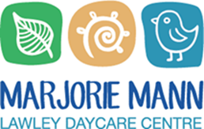

RECONCILIATION ACTION PLAN

August 2022 - August 2025
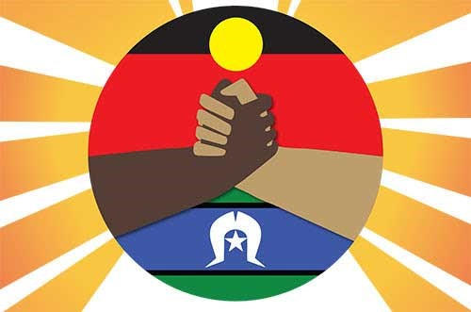

OUR VISION
Marjorie Mann Lawley Daycare Centre’s Vision for Reconciliation is to be encouragers. We want to be respectful of Culture, Language and of the identity of First Nations People. We also want the actions of Reconciliation to be part of our everyday practice.

Reconciliation at Marjorie Mann
REFLECTING ON OUR JOURNEY THUS FAR
This is our Centre’s third Reconciliation Action Plan and we have felt it important to start our RAP with a celebration of the actions we have taken to honour Aboriginal and Torres Strait Islander people, Culture, and identity. We have made the most of opportunities to learn and take action this year and these actions have benefitted children, educators and our community. This year, we reflected through conversations, reflective practice in our daily diaries and gathering educators’ perspectives via email and through an online survey.

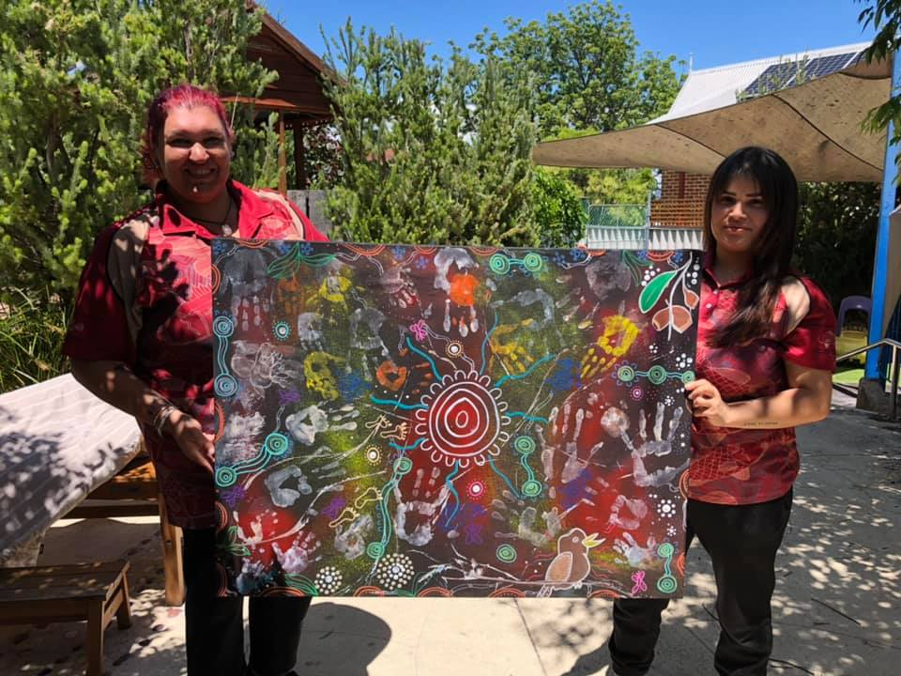
What Goals Did We Achieve?
- Partnerships: We pursued our goal of making connections in the community by partnering with local organization, FISH (Foundation for Indigenous Sustainable Health), sourcing resources from them and inviting them for art incursions here at the Centre. They supported us and we supported their efforts by donating an overstock of hats to share with children in remote communities who need them.
- Commissioning an Artwork: Together with Polly Wilson and Paris Pryor, children and educators were invited to create a collaborative artwork with these two talented Indigenous artists. They incorporated important symbols, our handprints as well as the kookaburra that visited the Toddlers garden on the day of their visit. It hangs proudly in our entry way.
- Important Days: We honoured National Celebrations with our children and community and shared about our actions and thinking on our daily documentation and social media accounts (NAIDOC Week, Reconciliation Week, Sorry Day)
- Embedding Indigenous Perspectives: Educators noted that they were proud to incorporate Indigenous perspectives throughout the year, not just in key celebration weeks.
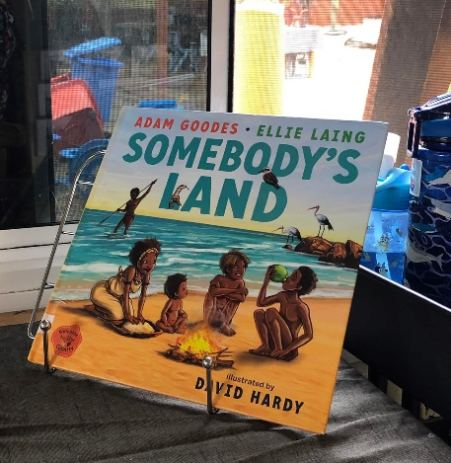
- Resourcing: We added new books and materials to our Centre, thanks to our relationship with the FISH Bookstore. The addition of these books supported learning for children and educators. We added many new children’s books and also a Noongar dictionary for educators to use.
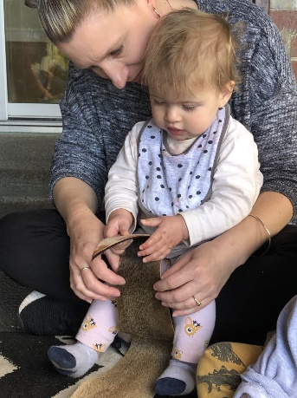
- Care for Country: The 2021 NAIDOC Theme of “Heal Country” inspired our sustainability program, modelling and teaching children about how we care for the planet and introducing a bush tucker garden.
- Art Incursions with FISH: In partnership with Aboriginal artists, Polly Wilson and Paris Pryor, our children had opportunities to create their own tapping sticks, read books from Indigenous authors and explore traditionally significant materials like quandong seeds, kangaroo skins, and emu feathers.

What Have We Learned?
- The importance of telling the truth about history. Children are really engaging with this learning and gaining a deeper understanding of Australian history.
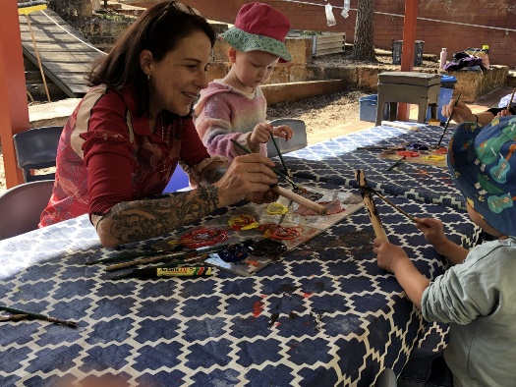
- How enriching it is for children and educators to engage with Indigenous people in our community. Our connections at FISH noted how special it was to share their Culture and stories with our children.
- That it is important to write the word Aboriginal with a capital letter when talking about people. This is a way that we can show respect.
- We have learned that our daily intentional teaching makes a tremendous difference for children’s learning and understanding. While reading “Somebody’s Land” by Adam Goodes and Ellie Laing, one of our Kindy children was very adamant that it wasn’t just somebody’s land, it is “Aboriginal people’s land!” We have also heard our kindy one children mention how important it is that we acknowledge Country at our daily meeting times.

What Didn’t We Achieve and Why?
- Supporting Staff Engagement with the RAP: When it came to reflecting on our RAP together and engaging our team with the plan, COVID added challenges as our Staff were unable to meet together for Team Meetings/Team Leader Meetings. These times to discuss and reflect supports us to take meaningful action together and we were limited in our ability to do this during this COVID season. Staff have also noted that having a copy of the RAP in each room would be helpful and that we can take action in different ways, like caring for our bush tucker garden.
- Continuing to use the Meeting Place symbol in all learning spaces: Although we continue to meet and acknowledge Country, the use of this symbol was not embedded across the Centre. Upon reflection, perhaps we could find a way to represent this symbol that is easy to move around and useable when meeting times/places/locations are flexible.
- Allocated Budget: We did not establish an allocated budget for our Reconciliation actions. Finances are incredibly tight but we did find ways to resource books for our program and fund incursion from our existing budget.
- Connecting with FISH: We did achieve this goal earlier in the year but as COVID ramped up in WA, our ability to connect was limited as our Centre closed to families and guess to protect our children and staff. We understand that the situation was difficult and are thankful that we were able to make the most of this relationship earlier in the year.

OUR JOURNEY
We have identified the following as the “next steps” of our journey:
ACTIONS:
- Reconnecting and collaborating with FISH (Foundation for Indigenous Sustainable Health) in the community to resource learning spaces, organise Indigenous Art incursions and to find ways we can help FISH reach its goals for supporting Aboriginal and Torres Strait Islander People. Donate our containers for change fundraising to FISH
- Continuing Acknowledgement to Country in every room with the children
- Investing time in connecting with local Indigenous people in our community
- Planning trainings, incursions and networking opportunities to continue learning from people in our community.
- Supporting educators to learn Language so they can share it with children
- Embedding Noongar language into our daily routines, starting with learning words about Country (water, sky, animals, soil etc)
- Making our respect for Country and First Australians visible the external entry area of our Centre. What could this look like? How do we show that this is a safe space?
- Adding Aboriginal and Torres Strait Islander Flags and an Acknowledgement of Country to our Centre website.
- Working to make a connection with a local Elder and hosting a Welcome to Country event at our Centre.
- Continue to tell the truth about history and share the stories of Aboriginal and Torres Strait Islander people with children.
- Find a way to include Reconciliation on our Group Learning Programs in an intentional way.
- For the children, continue to model respect for Country where we work and play. Understanding that the Whadjuk People are the traditional owners and custodians of this land.
- To include Aboriginal and Torres Strait Islander music, Language, artworks and stories in our daily curriculum.
- Inform families about our Reconciliation Action Plan and share our continuing journey of learning with our wider community.
- Continuing to celebrate NAIDOC Week, Reconciliation Week and National Sorry Day every year.
- Continue to grow bush tucker and use it in our cooking
We are committed to learning more about Aboriginal and Torres Strait Islanders culture and history, giving Country the respect that it deserves.

Marjorie Mann will review our RAP every three years and continue to support children and educators to learn and grow together. We will share what we have learned with families and the wider community in a way that is respectful of Aboriginal and Torres Strait Islanders. We want to support the ongoing efforts in Australia to advocate for Country and Culture, disrupting the systems and mindsets that continue to stand in the way of positive change and equality.

This Reconciliation Action Plan was created in August 2022 in consultation with:
Leadership Team, Educators and Staff of Marjorie Mann Lawley Day Care Centre. Our RAP Working Group was made up of Wendy Johns, Leanne Leggett, Susan Houston. Katrina Cox Business Development Manager at Foundation for Indigenous Sustainable Health and Ben Rose Service Lead Cultural Diversity and Community at the City of Stirling

This Reconciliation Action Plan is due for review in August 2025.

